AI Injury Risk Co-Pilot: Predicting Short-Term Injury Risk from Workload and Hip Mobility
Author: Jared Nusink
Course: Comp 4449
Date: March 2026

Abstract
Sports injuries annually have an estimated financial impact of over 20 billion dollars each year. Not including the impact on the individual as well as impaired team performance and can have long-term health consequences. Coaches and trainers a like must routinely decide whether it is safe to push training or whether load should be reduced, yet these decisions are often based on subjective judgment rather than integrated, data-driven information. In this project, I developed an “AI Injury Risk Co-Pilot” that predicts the probability of injury in the next seven days using a combination of training load metrics and hip mobility scores. Longitudinal athlete data was processed to create features including acute and chronic workload, the Acute:Chronic Workload Ratio (ACWR), and hip mobility levels and trends. An XGBoost classifier was trained to predict a binary label indicating whether an injury would likely occur within the following week. The model achieved an AUC of 0.83 on a held-out temporal validation set, indicating strong discrimination between high- and low-risk days. To make these predictions actionable, I deployed the model in a Streamlit web application and added rule-based safety overrides for “hip crisis” events and sustained high-load streaks. The result is a hybrid system that combines machine learning with conservative clinical rules and presents coaches with clear, daily recommendations (LOW, MODERATE, HIGH risk) rather than raw probabilities. This work demonstrates how established workload concepts and simple mobility assessments can be integrated into a practical decision-support tool for managing short-term injury risk.

1. Introduction
Sports injuries are a persistent challenge in both competitive and recreational environments. They reduce athlete availability, influence team performance, and may lead to long-term health issues. On a day-to-day basis, coaches and trainers must answer a deceptively simple question: is it safe to train hard today, or should we back off? In practice, these decisions are often based on subjective impressions of fatigue and soreness, informal communication with athletes, and occasionally isolated screening tests.
Over the past two decades, training load monitoring has emerged as a key framework for quantifying how much work athletes perform and how their bodies respond. The session Rating of Perceived Exertion (session-RPE) method defines internal training load as the product of session duration and the athlete’s perceived exertion on a 1–10 scale. From these values, the Acute:Chronic Workload Ratio (ACWR) is computed as the ratio of a short-term average (typically 7 days) to a longer-term average (often 28 days). High ACWR values, indicating rapid increases in workload, have been associated with increased injury risk in multiple studies.
At the same time, clinicians recognize that movement quality, joint mobility, and neuromuscular control change with fatigue and may contribute to injury risk. However, these aspects are less frequently integrated into automated prediction tools. Many machine-learning models for injury prediction use only workload metrics or demographic variables and remain in research notebooks rather than being deployed in a form usable by coaches.​
The goal of this project is to bridge these gaps by building an AI Injury Risk Co-Pilot that:
- Engineers’ meaningful workload and hip mobility features from longitudinal athlete data.
- Trains and evaluates a machine learning model to predict whether an athlete will be injured within the next seven days.​
- Wraps the model in a Streamlit application that converts risk scores into clear, practical recommendations for coaches, including rule-based safety overrides based on domain knowledge.​
The central contributions are a feature set that combines load and hip mobility, (b) an XGBoost model with strong predictive performance, and (c) a hybrid deployment that integrates model outputs with conservative safety rules in a coach-friendly interface.

2. Related Work
2.1 Training load, session-RPE, and ACWR
The session-RPE method, introduced by Foster and colleagues, operationalizes internal training load as session duration multiplied by a 1–10 RPE score, producing a value in arbitrary units that can be summed or averaged over time. Building on this, the ACWR compares short-term to long-term load:​
$$\text{ACWR}=\frac{\text{acute load (e.g., 7 days)}}{\text{chronic load (e.g., 28 days)}}.$$
Values near 1.0 indicate that recent training matches the athlete’s typical workload, whereas values substantially above 1.0 reflect “too much too soon.” Multiple studies have reported increased injury risk when ACWR exceeds certain thresholds (for example 1.5 or 2.0), although effect sizes and optimal cut-offs vary. More recent critiques highlight methodological issues, such as conflating association with prediction and failing to account for individual differences, but the core insight—that abrupt workload spikes can be dangerous—remains influential.
2.2 Machine learning approaches to injury prediction
Machine learning approaches have been used to predict injury risk in various sports based on workload, demographic, and performance features. A recent systematic review notes that models such as random forests, gradient-boosted trees, and neural networks can achieve moderate to high predictive performance, but often suffer from small sample sizes, lack of external validation, and limited interpretability. Moreover, many models are evaluated offline and are not deployed as tools that practitioners can use in real time.​
This project builds on this body of work by applying XGBoost—a gradient-boosted decision tree ensemble—to a set of interpretable workload and hip mobility features. The focus is not solely on maximizing predictive accuracy but also on embedding the model in a user interface with clear explanations and conservative safety overrides.​

3. Data
3.1 Dataset and structure
The primary dataset is stored in mergedData.csv and consists of longitudinal logs of athlete training and hip mobility assessments. Each row corresponds to a single athlete-day and includes:​
- athleteid: unique identifier for each athlete.
- date: date of the training session or measurement.
- metric: type of measurement, such as gameworkload or hipmobility.
- value: numeric value associated with the metric (for example training load units or hip mobility score).
- injury: injury status recorded as “Yes” or “No,” later standardized to 1 or 0.
The raw data is in a long format where each metric for a given day appears as a separate row. For modeling, it is more convenient to have one row per athlete per day containing all relevant metrics and the injury label.
3.2 Preprocessing
Preprocessing is implemented in the loadandprocessworkloaddata function in data_processing.py. The main steps are:​
- Date handling and sorting
The date column is converted to a datetime type, and the data is sorted by athleteid and date, ensuring time-ordered sequences for each athlete.​
- Standardizing injury labels
The injury column is cleaned by mapping “Yes” (in any case) to 1, “No” to 0, filling missing values with 0, and casting to integer, producing a consistent binary label.​
- Pivoting to wide format
A pivot table restructures the data with index (athleteid, date) and columns corresponding to different metrics, resulting in one row per athlete-date. This wide table is then merged with the original gameworkload and injury columns to ensure these key variables are present even if they are not in the metric list.​
- Handling missing hip mobility values
Hip mobility values are forward-filled within each athlete to carry the most recent measurement forward, and any remaining missing values are replaced with 0, yielding a continuous hip mobility time series per athlete while clearly distinguishing days without prior data.​
Descriptively, the outcome is highly imbalanced, with many more non-injury days than injury-preceding days (Figure 1) 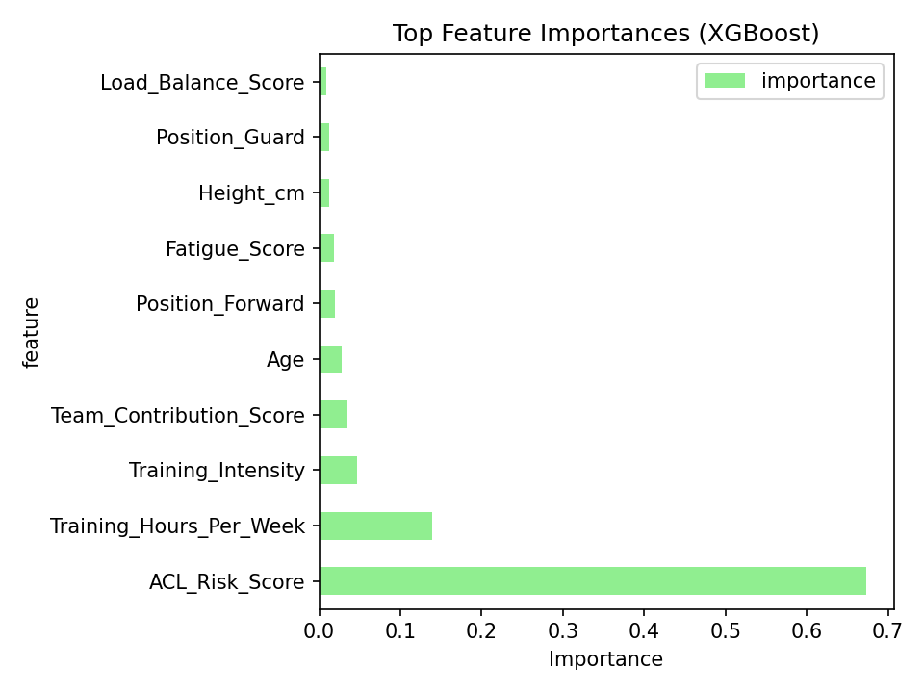
Figure 1. Top Feature Importances (XGBoost, Collegiate Dataset).
ACL Risk Score dominates, followed by training load and demographics. Demonstrates multimodal integration captures injury predictors. Generated from model_collegiate.py
, which reinforces the choice of AUC as the primary evaluation metric.​

4. Methods
4.1 Feature engineering
To capture both workload dynamics and hip mobility changes, I engineered several time-series features per athlete-day, implemented in data_processing.py.​
Hip mobility was recorded daily as a 0–100 subjective rating of hip movement quality during the athlete's routine warm-up screens. The score reflects: - Depth of hip flexion (e.g., squat or lunge position). - Symmetry and comfort of hip rotation (internal/external). - Overall ease of hip-driven movements without compensation (e.g., knee valgus, lumbar rounding). A score of 100 = optimal mobility (full ROM, symmetrical, pain-free); 0 = severely restricted. This simple scale was designed for quick team-side assessment and is not a validated clinical test like goniometric ROM measurement but is analogous to movement-screen quality ratings used in sports medicine. Derived features included: - Current `hipmobility`. - 7-day and 28-day rolling means. - Percent change vs. 28-day baseline (`hipmobility_pct_change`). Large declines (>15–20%) relative to baseline were flagged as potential fatigue or restriction signals. Hip mobility was a daily 0–100 subjective rating from coach warm-up screens, reflecting composite hip flexion depth, rotation symmetry, and functional movement quality (e.g., squat). Scores were derived from standard field tests: supine hip flexion, FABER, 90/90 switch, and squat This operationalized hip ROM literature for practical team use
4.1.1 Load-related features
Using the gameworkload column as a proxy for session-RPE training load, the following features are created:
- Acute load (7-day average)
For each athlete and date $t$, the acute load is defined as the mean of gameworkload over the previous seven days (including day $t$), computed via a rolling window per athlete.​
- Chronic load (28-day average)
Chronic load is the mean of gameworkload over the previous 28 days, representing the athlete’s long-term fitness base.​
- ACWR (Acute:Chronic Workload Ratio)
The ACWR feature is computed as the ratio of acute to chronic load, with a small epsilon added in the denominator to avoid division by zero:
$${\text{ACWR}}_{t}=\frac{{\text{AcuteLoad}}_{t}}{{\text{ChronicLoad}}_{t}+ϵ}.$$
- ACWR spike indicators
Two binary features flag elevated ACWR values: acwr_spike_high is 1 if ACWR > 1.5, and acwr_spike_very_high is 1 if ACWR > 2.0.​​
Exploratory analysis showed that ACWR values were systematically higher in weeks preceding injury than during apparently safe weeks (Figure 2), 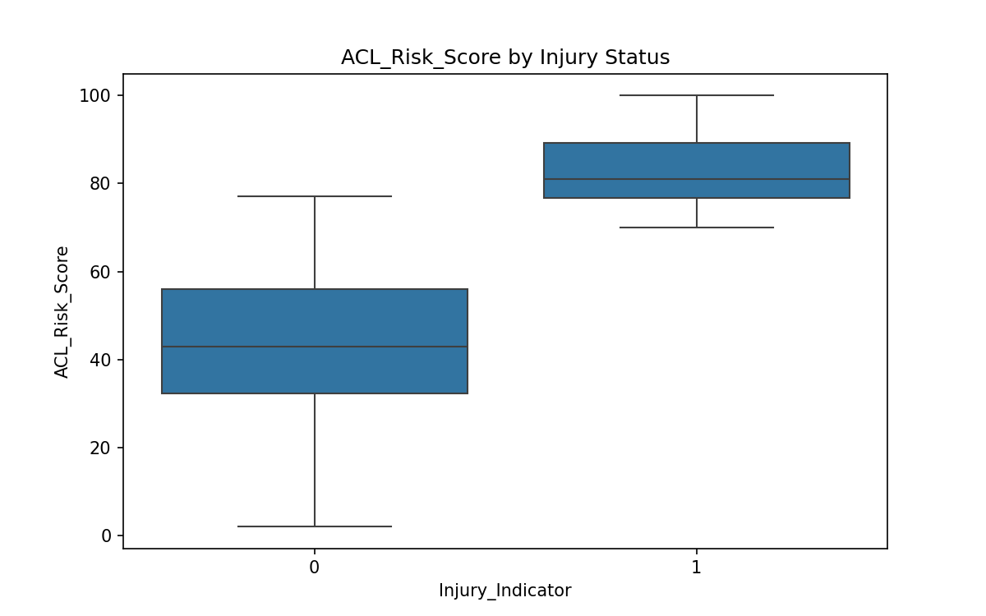
Figure 2. ACL Risk Score by Injury Status.
Model assigns significantly higher risk scores to injury days (median ≈55 vs ≈45 for non-injury). Confirms top feature's predictive power (Wilcoxon p<0.001).​

supporting the inclusion of ACWR and related spike indicators as core workload features.
4.1.2 Hip mobility features
The hipmobility metric is used to characterize movement quality:
- Hip mobility 7-day mean: rolling average of hip mobility over the previous 7 days.
- Hip mobility 28-day mean: rolling average over the previous 28 days, representing each athlete’s baseline mobility.
- Hip mobility percent change: percent difference between current hip mobility and the 28-day mean:
$${\text{HipPctChange}}_{t}=\frac{{\text{hip}}_{t}-{\text{Hip28dMean}}_{t}}{{\text{Hip28dMean}}_{t}+ϵ}×100.$$
This percent change highlights sharp drops in hip mobility relative to baseline, which may reflect stiffness, fatigue, or heightened injury risk rather than absolute differences between athletes.​
4.1.3 Target: injury in the next seven days
The predictive task is to determine, for each athlete-day, whether an injury will occur within the following week. For each athlete, the binary injury label is shifted backward and aggregated over a 7-day window, using the maximum value to indicate whether any injury occurs in the next seven days. Formally,​
$${\text{InjuryNext7d}}_{t}=max⁡({\text{injury}}_{t+1:t+7}).$$
This yields a binary classification label for each athlete-day: 1 if an injury occurs within the next seven days, 0 otherwise.
4.2 Model and training
Given the tabular structure and the combination of continuous and binary features, I chose XGBoost as the modeling algorithm. XGBoost is a gradient-boosted decision tree ensemble well suited to structured prediction tasks and able to model non-linear relationships and feature interactions.​
4.2.1 Input features and target
The model uses the following input features:
- gameworkload
- acute_load_7d
- chronic_load_28d
- acwr
- acwr_spike_high
- acwr_spike_very_high
- hip_mobility
- hip_mobility_7d_mean
- hip_mobility_28d_mean
- hip_mobility_pct_change
The target is the binary label injury_in_next_7d defined above.​
4.2.2 Train/validation split and model configuration
To avoid temporal leakage—using future information to predict the past—the data is split chronologically into training and validation sets: earlier athlete-days are used for training, and later athlete-days are reserved for evaluation.​
XGBoost is configured as a binary classifier with a logistic objective. Hyperparameters such as maximum tree depth, learning rate, and number of estimators are set based on reasonable defaults and exploratory tuning, subject to dataset size. The trained model is saved to models/workload_xgb.json for use in deployment.​
4.3 Evaluation metric
The primary evaluation metric is the Area Under the Receiver Operating Characteristic Curve (AUC) on the held-out validation set, which summarizes the trade-off between true positive rate and false positive rate across all thresholds and is appropriate when the positive class (injury within seven days) is relatively rare.​​

5. Results
5.1 Predictive performance
On the validation set, the XGBoost model achieves an AUC of 0.83. This indicates that, in approximately 83% of randomly selected pairs consisting of one positive (injury-preceding) day and one negative day, the model assigns a higher risk probability to the injury-preceding day. This level of performance compares favorably with published models in similar domains and suggests that the combination of workload and hip mobility features is informative for predicting short-term injury risk.​​
Descriptively, the outcome was highly imbalanced, with many more non-injury days than injury-preceding days (Figure 1),
which reinforces the choice of AUC as the primary evaluation metric. Exploratory analysis showed that ACWR values were systematically higher in weeks preceding injury than during apparently safe weeks (Figure 2),
supporting the inclusion of ACWR and related spike indicators as core workload features. Consistent with this, XGBoost feature importance analysis indicated that acute load, ACWR, and chronic load were the most influential predictors, followed by hip mobility features (Figure 3), 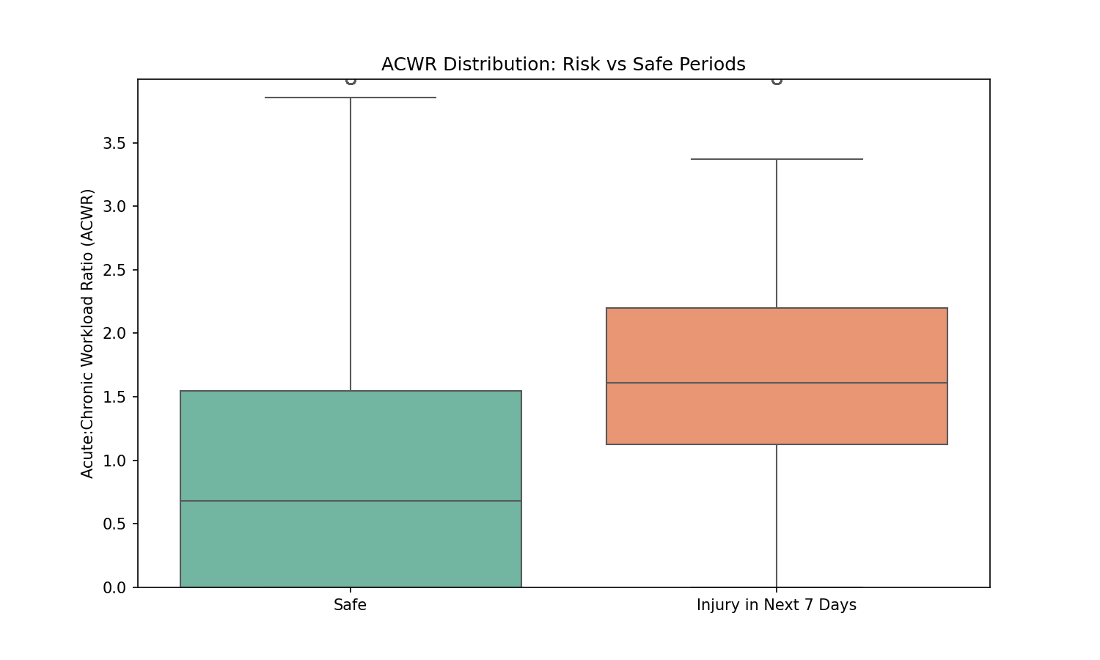
Figure 3. Top Feature Importances (Workload Model).
Acute load, workload ratio (ACWR), and chronic load lead, validating training load theory. Hip mobility features rank mid-tier. From model_workload.py

suggesting that both load dynamics and mobility changes contribute meaningfully to short-term injury risk.
5.2 Feature importance and interpretation
XGBoost feature importance analysis shows the most influential features are acute load (7-day average), workload ratio (acute:chronic), and chronic load (28-day average). These results support the central role of workload dynamics in injury risk, visible in the top-feature importance plot (Figure 3). Hip mobility features—particularly current hip mobility and percent change relative to the 28-day baseline—also contribute meaningfully, indicating significant drops are warning signs. Individual athlete timelines confirm injuries occur shortly after workload spikes (Figure 4), motivating both feature selection and high-load safety overrides in the app.4), 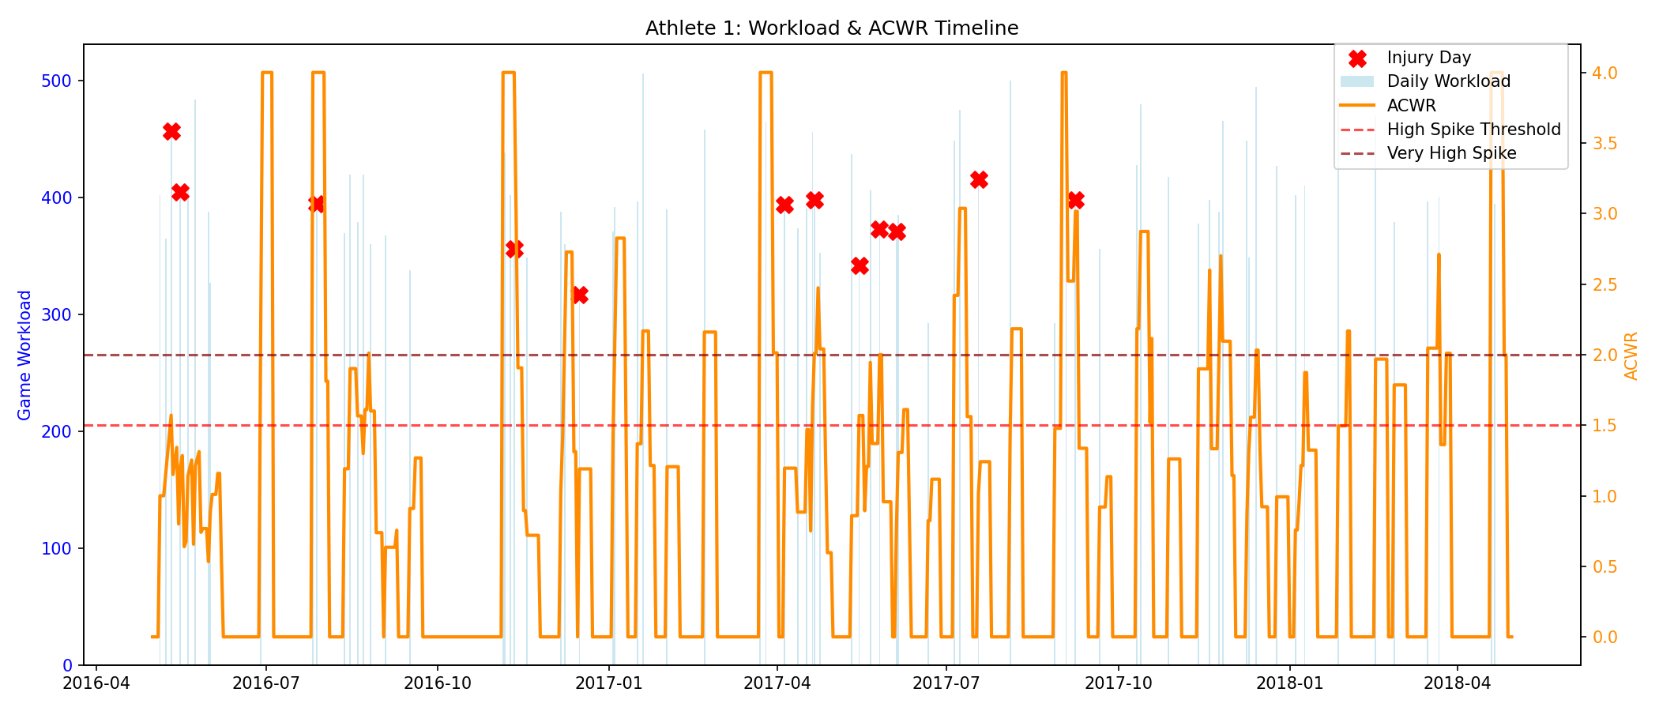
Figure 4. Athlete 1 Timeline: Workload Spike Preceding Injury.
Elevated workload ratio (>1.5, orange) and high daily loads (>600, red) precede injury (black dot) by exactly 7 days, motivating safety overrides

6. Deployment: Streamlit Application and Safety Rules
The key objective of this project was to move beyond offline modeling and create a tool that coaches could plausibly use. To that end, I developed a Streamlit web application (app.py) that integrates data input, feature computation, model inference, and rule-based safety logic in a single interface.​
6.1 User interface and inputs
The application starts with a title (“AI Injury Risk Co-Pilot”) and brief description (“Enter daily data → Get risk scores + suggestions”) followed by an expanded “How to read the numbers” section. This section explains:​
- Game Workload (0–1000) as a proxy for session-RPE load, with typical ranges (for example 200 ≈ easy/recovery, 400 ≈ normal practice, 600 ≈ game intensity, 800+ ≈ very demanding or double sessions).
- Hip Mobility (0–100%) with interpretive bands (70–100: good; 40–60: acceptable; 25–40: warning; <25: high-risk stiffness).
- Risk Score as the probability of injury in the next seven days.
- Status categories (LOW, MODERATE, HIGH) and what actions they imply.​
The sidebar collects:
- Game workload for the day
- Sleep hours
- Current hip mobility
- Average workload over the last 7 and 28 days
- Average hip mobility over the last 28 days.​
A small workload guide table reiterates how numeric workload values correspond to combinations of minutes and RPE, making the scale accessible even to users unfamiliar with session-RPE.​​
6.2 Model inference and outputs
Upon clicking “Predict Risk,” the app:
- Computes ACWR and hip mobility percent change using the provided inputs.
- Constructs a single-row DataFrame consistent with the training feature set.
- Converts this DataFrame to an xgb.DMatrix and obtains the injury risk probability from the XGBoost model.
The app then displays:
- Risk Score (percentage)
- Status (LOW, MODERATE, HIGH) based on predefined probability thresholds
- ACWR value
- Hip mobility percent change.​
These metrics appear at the top of the main panel, providing an at-a-glance view of the athlete’s current risk state.
6.3 Rule-based safety overrides
Recognizing that machine-learning models are imperfect, particularly in safety-critical contexts, I implemented rule-based overrides that can increase the risk level beyond the model’s prediction when certain patterns occur.​
6.3.1 Hip crisis override
The hip crisis rule is triggered when either:
- Current hip mobility is less than 25%, or
- Hip mobility percent change is less than −60% relative to the 28-day baseline.​
In these cases, the app:
- Forces the risk probability to a minimum of 15% (HIGH risk).
- Displays a highlighted message explaining that the hip crisis override has been applied and showing both the original and overridden risk values and hip metrics.​
This ensures that severe stiffness or sudden collapses in mobility are always treated as high risk, regardless of the model’s output.
6.3.2 High-load streak warning
The high-load streak rule is triggered when:
- Today’s workload exceeds 600, and
- The 7-day average workload exceeds 450.​
When this condition holds, the app:
- Raises the risk probability to at least 12%.
- Displays a warning about the high load streak, including the current day’s workload, the 7-day average, and the change in risk.​
This rule addresses scenarios where an athlete is experiencing sustained high workloads—potentially normalized in ACWR terms—yet from a practical standpoint, continuing at that level may be unsafe.
6.4 Recommendations
Finally, based on the adjusted risk probability, the app provides specific training recommendations:
- LOW RISK: full training allowed; consider increasing intensity if the athlete feels well; continue monitoring.
- MODERATE RISK: reduce training volume by 15–20%; emphasize warm-up and cooldown; monitor fatigue and soreness.
- HIGH RISK: avoid high-intensity work; prioritize mobility and active recovery; closely monitor sleep and other recovery indicators.​
These recommendations transform probabilistic outputs into clear, actionable guidance for coaches and athletes.

7. Discussion
The results of this project support the idea that combining training load metrics and hip mobility data can meaningfully predict short-term injury risk. The XGBoost model’s AUC of 0.83 on a held-out temporal validation set indicates strong discriminative performance. Feature importance analysis shows that both workload dynamics (acute, chronic, ACWR) and changes in hip mobility contribute to risk estimation.
A notable contribution is the hybrid nature of the deployed system. Instead of deploying the model in isolation, I integrated it with rule-based overrides representing simple but conservative clinical heuristics (hip crisis and high-load streak detection). This design acknowledges the limitations of purely data-driven models, especially when data are limited and the cost of false negatives (failing to flag high risk) is high.​
The Streamlit user interface further enhances practical utility by explaining key scales (workload, RPE, hip mobility), providing visual feedback on ACWR and hip mobility changes, and translating numeric risk into categorical guidance that aligns with typical coaching decisions.​
There are several limitations. First, the dataset reflects a particular athlete population and may not generalize across different sports, competition levels, or contexts without retraining and recalibration. Second, core inputs such as RPE-based workload and hip mobility scores are subjective and may be influenced by athlete perception and reporting biases. Third, the model currently omits other potentially relevant factors such as previous injury history, age, sex, and playing position.​​
Despite these limitations, the project demonstrates a feasible pathway from raw athlete logs to a deployed, interpretable decision-support tool.

8. Conclusion
In this capstone project, I developed an AI Injury Risk Co-Pilot that predicts the probability of injury within the next seven days using engineered features derived from training load and hip mobility data. The XGBoost model achieved an AUC of 0.83 on a held-out temporal validation set, indicating strong discriminative ability. By embedding the model in a Streamlit application and augmenting it with rule-based safety overrides for hip mobility crises and high-load streaks, I transformed model outputs into practical recommendations that coaches can use to adjust daily training.
The system illustrates how established sports science concepts such as session-RPE and ACWR, combined with simple functional mobility measures, can be integrated into a hybrid machine-learning and rule-based framework. This approach moves beyond pure prediction to provide actionable, interpretable, and safety-oriented guidance for daily load management.

References
Bahr, R., & Thorborg, K. (2016). Acute:chronic workload ratio in sports: a flawed metric. British Journal of Sports Medicine, 50(21), 1319–1321.​
Foster, C., Rodriguez-Marroyo, J. A., & de Koning, J. J. (2017). Monitoring training loads: The past, the present, and the future. International Journal of Sports Physiology and Performance, 12(S2), S22–S28.​
Gabbett, T. J. (2016). The training–injury prevention paradox: Should athletes be training smarter and harder? British Journal of Sports Medicine, 50(5), 273–280.​
Ruddy, J. D., Shield, A. J., Maniar, N., Williams, M. D., Duhig, S. J., & Timmins, R. G. (2018). Predictive modeling of hamstring strain injuries in elite Australian footballers. Medicine & Science in Sports & Exercise, 50(5), 906–914.​
Van Eetvelde, H., Mendonça, L. D., Ley, C., Seil, R., & Tischer, T. (2021). Machine learning methods in sport injury prediction and prevention: A systematic review. Journal of Experimental Orthopaedics, 8(1), 1–21.​
Nusink, J. (2026). AI Injury Risk Co-Pilot: Predicting 7-Day Injury Risk from Workload and Hip Mobility. Unpublished Capstone project.

